**Manual QA Engineer test**

13.11.2023

**─**  
Branko Jovovic  
  
  
**BUG 1 - Frontend**  
**Summary Sign in, cart and Info are not aligned properly**

**Description:**The user can notice that sign in, cart and Info are not aligned properly

**Environment:**

- Chrome : Version 119.0.6045.124 (Official Build) (64-bit)

- Operating System: Windows 10

**Steps to Reproduce:**

1. Open the web browser.

2. Navigate to the (URL:https://petstore.octoperf.com/actions/Catalog.action).

3. Observe the Sign in cart and info in the header.

**Expected Behavior:**

- The Sign in cart and info in the header should be aligned properly

**Attachments:  
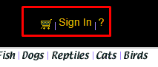**

**Additional Information:**

- This issue is consistent and reproducible.

- Clearing browser cache and cookies did not resolve the problem.

- No browser extensions are affecting the login process.  
  
**Priority:**

- High

**Severity:**

- High

**Labels:**

- Bug, Header, UI

**BUG 2 - Backend**  
  
**Summary Website not aligned properly in browser**

**Description:**The user can notice that header, body and footer are not properly aligned in the browsers. The behavior is attached in screenshot.

**Environment:** - Chrome : Version 119.0.6045.124 (Official Build) (64-bit)

- Operating System: Windows 10

**Steps to Reproduce:**1. Open the web browser.

2. Navigate to the (URL:<https://petstore.octoperf.com/actions/Catalog.action>).  
3. Observe the website

**Expected Behavior:**The website is properly aligned from top to bottom of the screen.

**Attachments:  
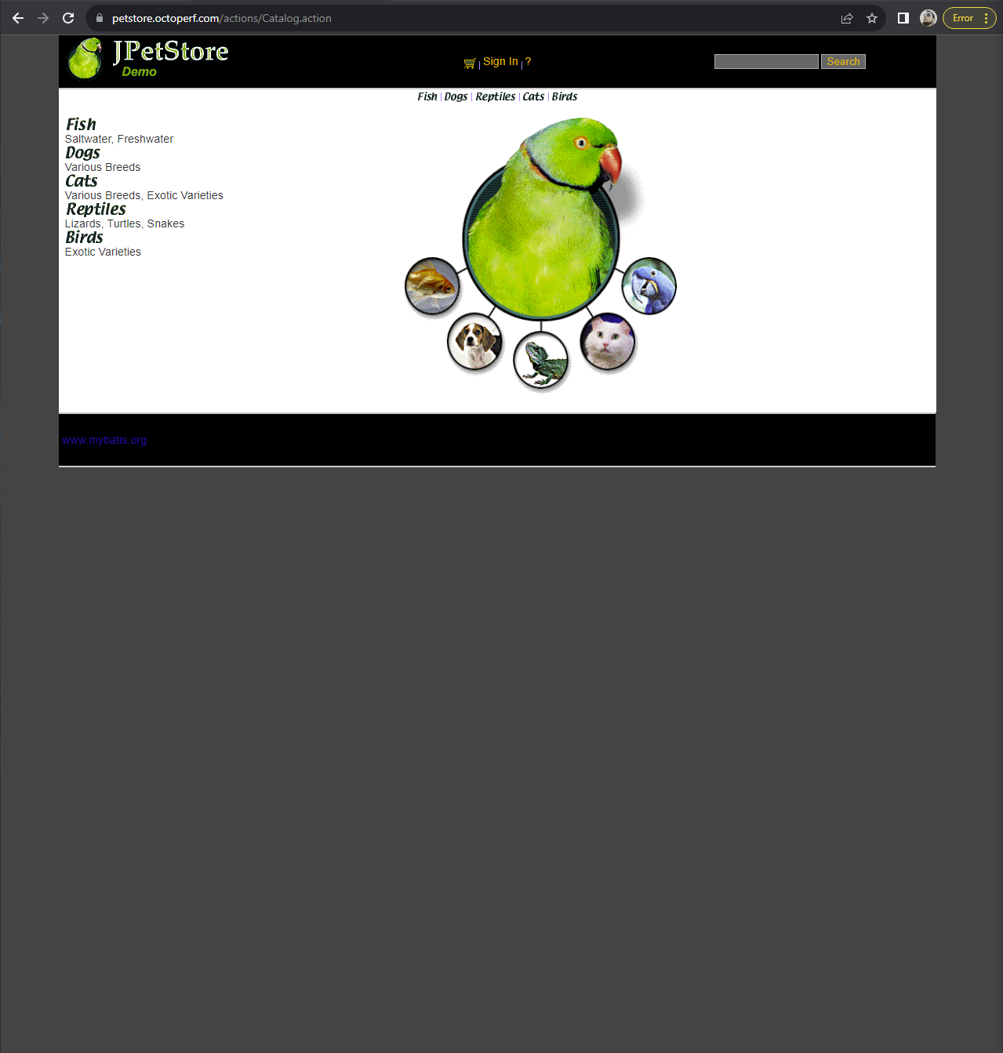**

**Additional Information:** - This issue is consistent and reproducible.

- Clearing browser cache and cookies did not resolve the problem.

- No browser extensions are affecting the login process.

**Priority:**High

**Severity:**Major

**Labels:** - Bug, UI

**Bug 3 - Backend**  
  
**Summary Server error upon registration**

**Description:**The user can notice that when on registration page, and input any number as User ID and try to complete registration, the error appears. THe user should also not be able to generate server ID and edit that option.

**Environment:** - Chrome : Version 119.0.6045.124 (Official Build) (64-bit)

- Operating System: Windows 10

**Steps to Reproduce:**1. Open the web browser.  
2. Navigate to the (URL:<https://petstore.octoperf.com/actions/Catalog.action>).  
3. Navigate to registration when tapping “Sign in” from header.

**Expected Behavior:**The user should not be able to create custom UID, which should be self generated. Leaving that option for the user to change produces site error.

**Attachments:  
  
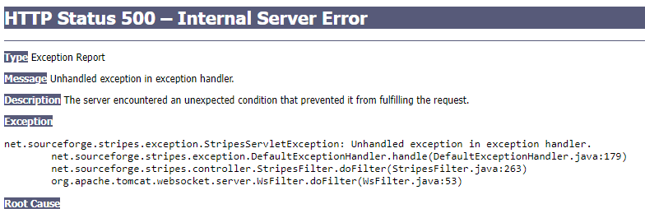  
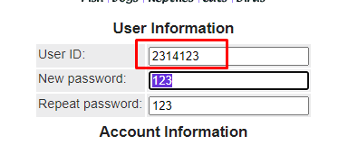**

**Additional Information:** - This issue is consistent and reproducible.

- Clearing browser cache and cookies did not resolve the problem.

- No browser extensions are affecting the login process.

**Priority:**HIGH

**Severity:**Blocker

**Labels:** - Bug,Registration,UI **BUG 4 - Backend  
  
Summary: Invalid search produces website to resize.**

**Description:**The user can notice that when inputting any other info instead of product name, the website gives results as shown in screenshot.

**Environment:** - Chrome : Version 119.0.6045.124 (Official Build) (64-bit)

- Operating System: Windows 10

**Steps to Reproduce:**1. Open the web browser.  
2. Navigate to the (URL:<https://petstore.octoperf.com/actions/Catalog.action>).  
3. Navigate to “Search” bar on top right corner in header

**Expected Behavior:**The user should get feedback info that product is not existing or it should offer product with given keywords.

**Attachments:  
  
**

**Additional Information:** - This issue is consistent and reproducible.

- Clearing browser cache and cookies did not resolve the problem.

- No browser extensions are affecting the login process.

**Priority:**High

**Severity:**Medium

**Labels:** - Bug,Search bar,UI **BUG 5 -Backend  
Summary : Purchase limit on single item  
  
Description:**The user is able to put a huge amount of product in the cart without limitations.

**Environment:** - Chrome : Version 119.0.6045.124 (Official Build) (64-bit)

- Operating System: Windows 10

**Steps to Reproduce:**1. Open the web browser.  
2. Navigate to the (URL:<https://petstore.octoperf.com/actions/Catalog.action>).  
3. Navigate to any item and add it to cart  
4. In the cart change value for the item to 100000+

**Expected Behavior:**The user should have a limit upon purchasing a single item .

**Attachments:  
  
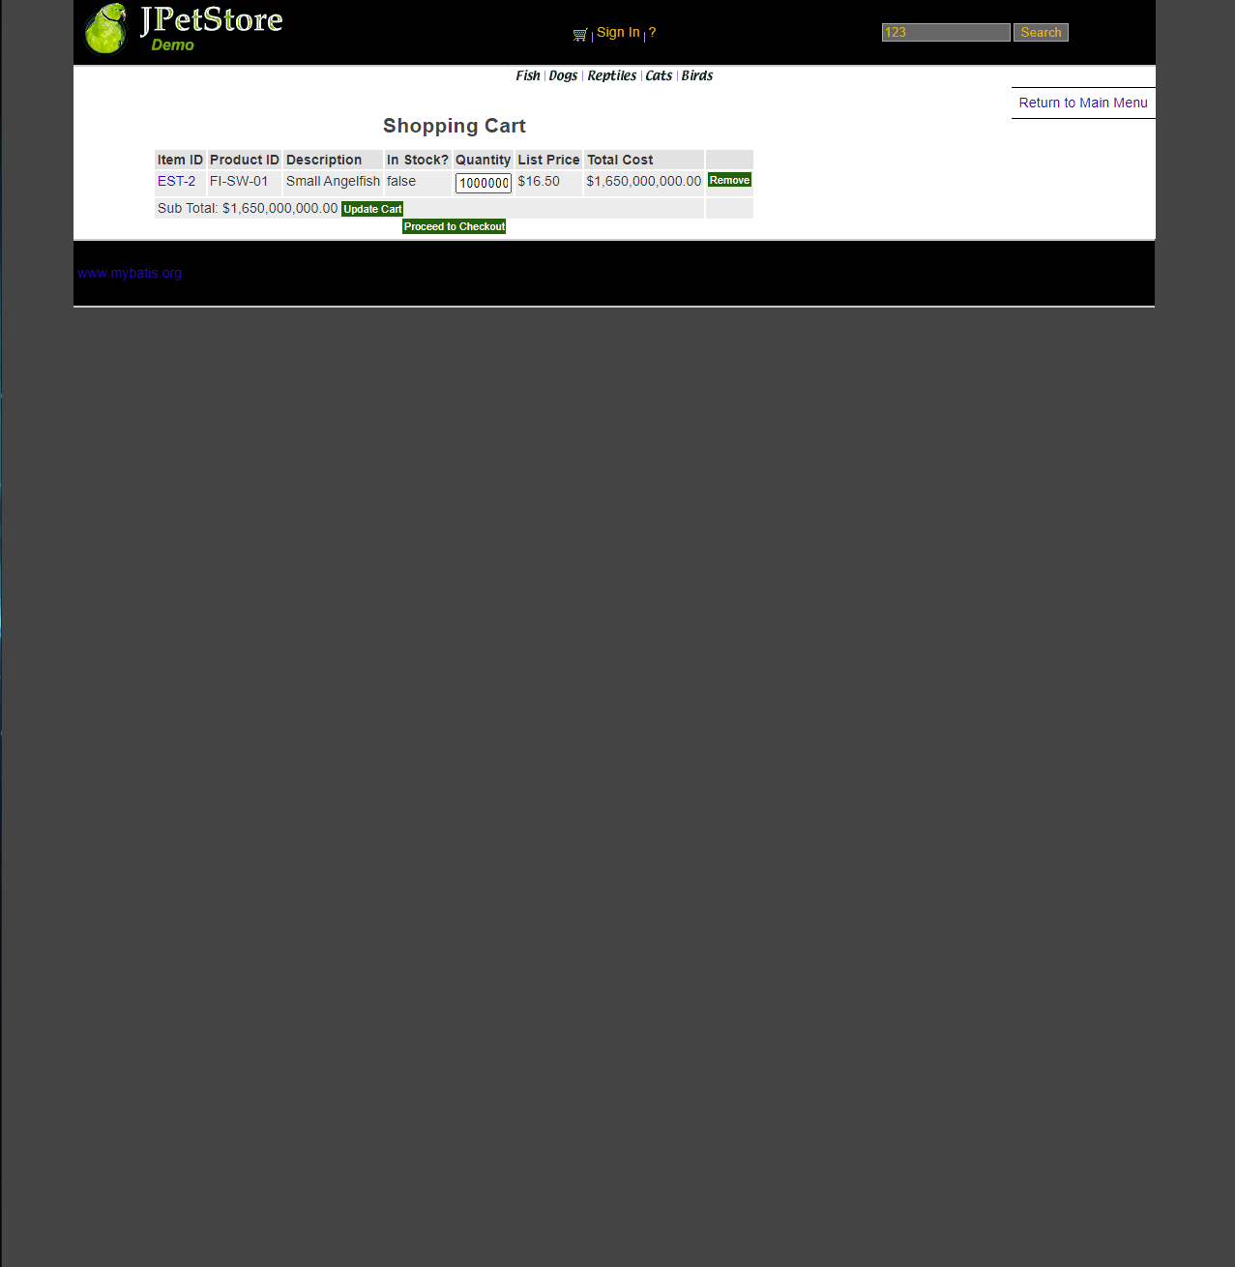**

**Additional Information:** - This issue is consistent and reproducible.

- Clearing browser cache and cookies did not resolve the problem.

- No browser extensions are affecting the login process.

**Priority:**High

**Severity:**Major

**Labels:**

- Bug,Cart

**BUG 6 - Backend  
Summary “Known issues” link not working**

**Description:**The user can notice when clicking on “Known issues”it is not linked.

**Environment:** - Chrome : Version 119.0.6045.124 (Official Build) (64-bit)

- Operating System: Windows 10

**Steps to Reproduce:**1. Open the web browser.  
2. Navigate to the (URL:https://petstore.octoperf.com/help.html#Issues).  
3. Tap on the “Known issues”

**Expected Behavior:**The user should be able to click on “Known issues”

**Attachments:  
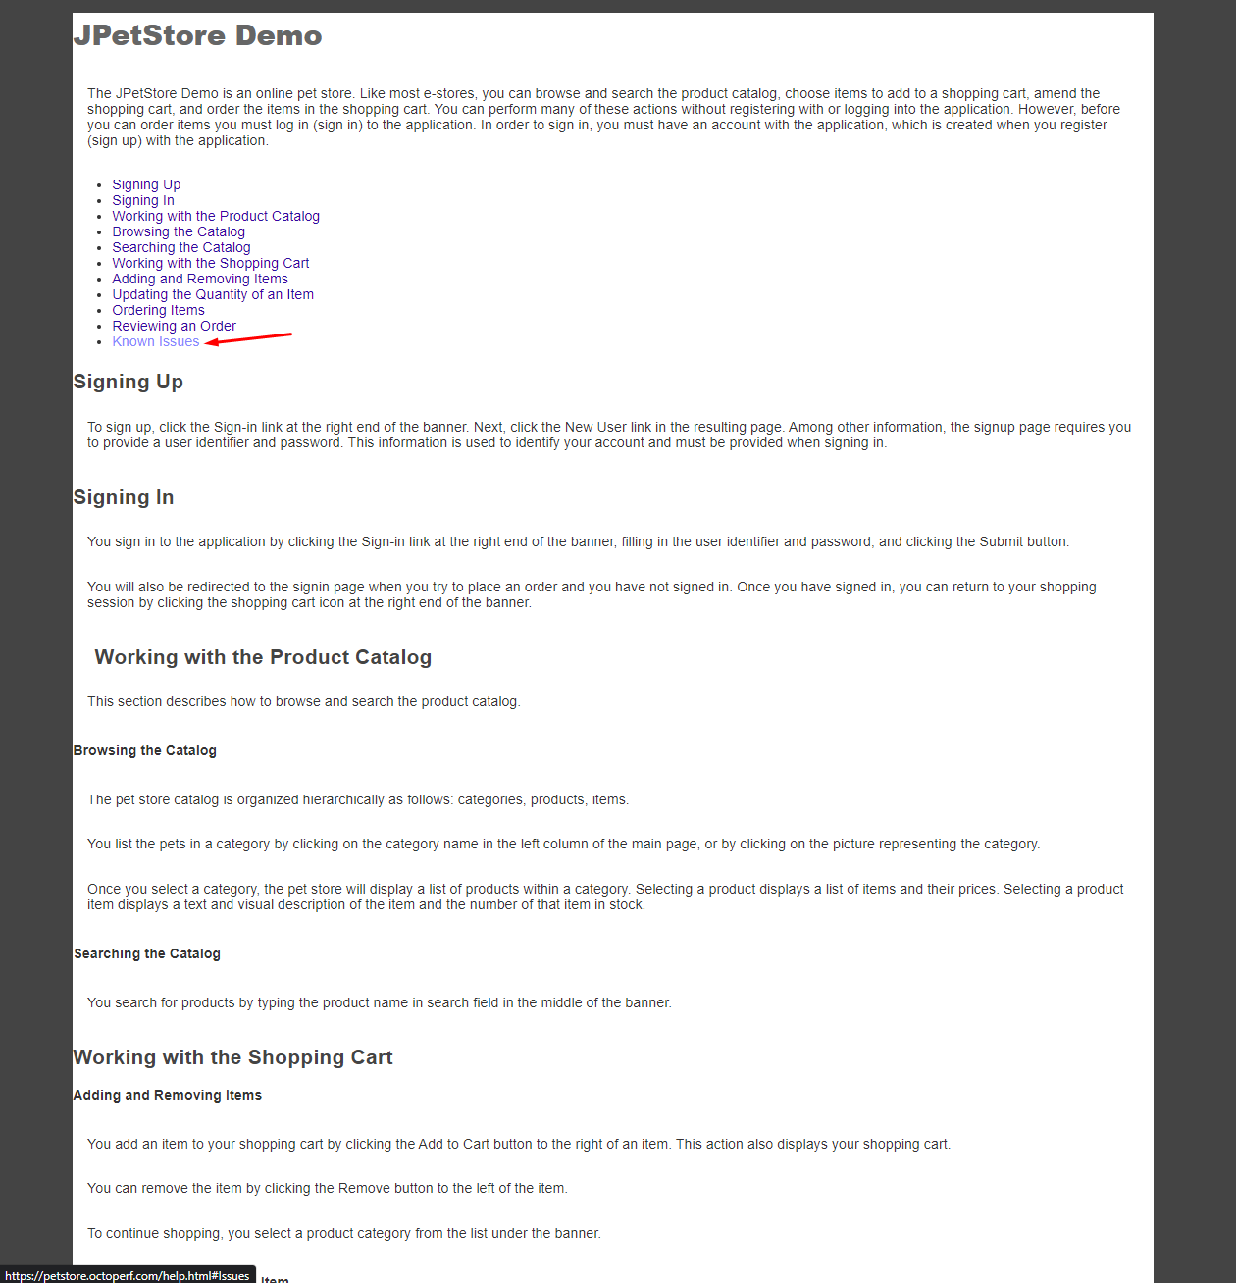**

**Additional Information:** - This issue is consistent and reproducible.

- Clearing browser cache and cookies did not resolve the problem.

- No browser extensions are affecting the login process.

**Priority:**Low

**Severity:**Minor

**Labels:  
UI,Link,Help**

**BUG 7- Backend   
Summary FAQ menu do not have linked back to home page when pressing Logo (Store name)**

**Description:**The user should be able to go back to home page upon pressing JP logo or store name.

**Environment:** - Chrome : Version 119.0.6045.124 (Official Build) (64-bit)

- Operating System: Windows 10

**Steps to Reproduce:**1. Open the web browser.  
2. Navigate to the (URL:https://petstore.octoperf.com/help.html#Issues).  
3. Tap on the logo or name of the store

**Expected Behavior:**The user should be able to click and go back to homepage.

**Attachments:  
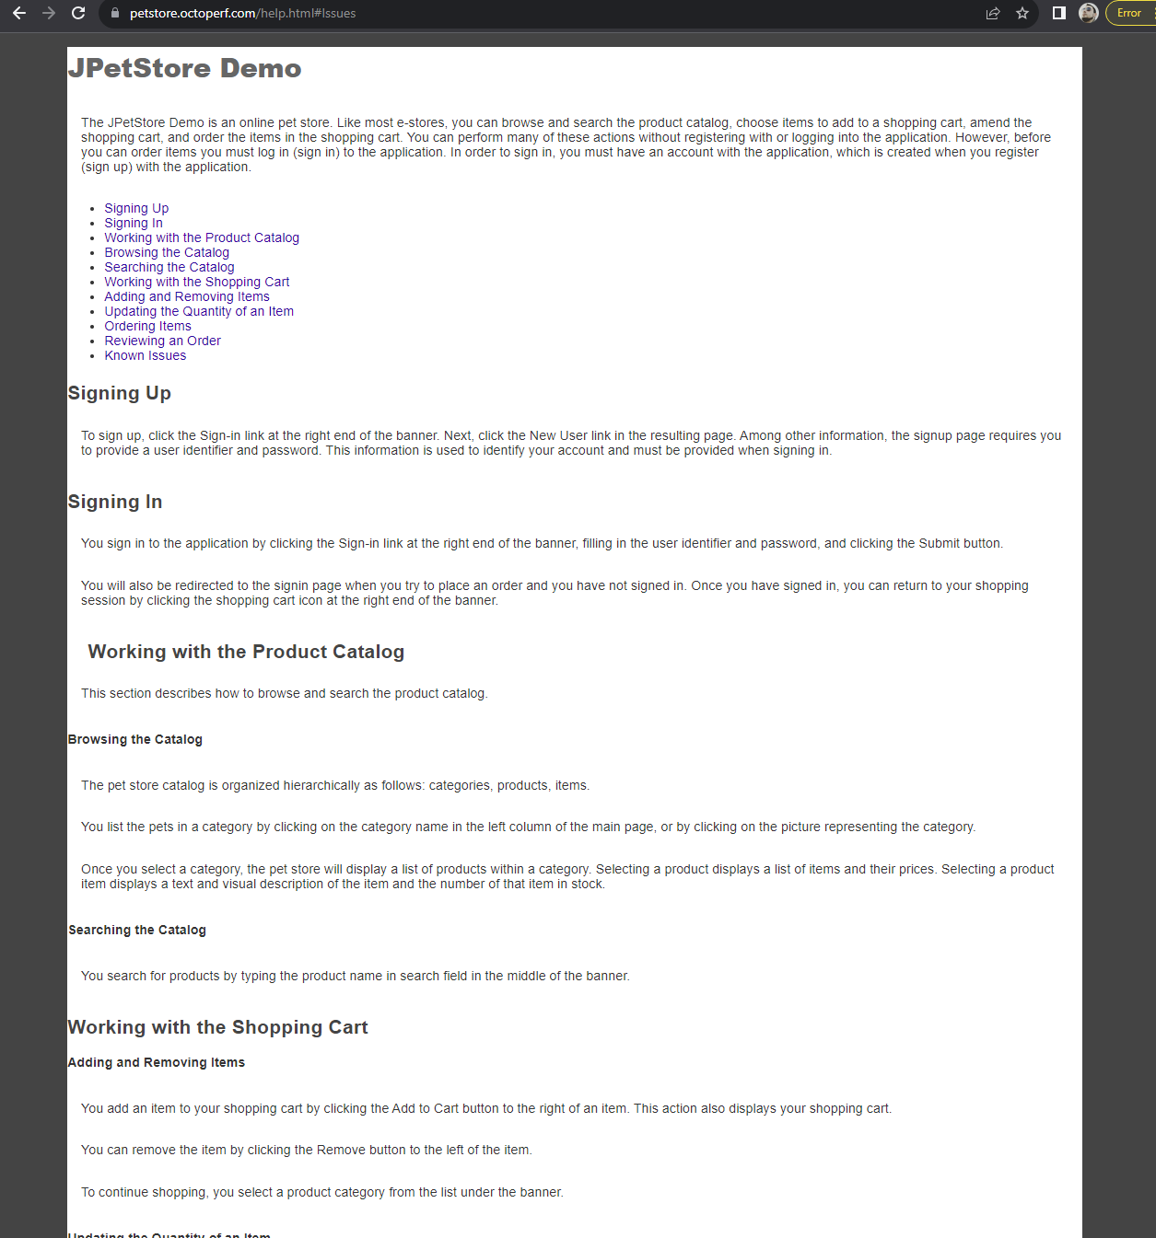**

**Additional Information:**- This issue is consistent and reproducible.

- Clearing browser cache and cookies did not resolve the problem.

- No browser extensions are affecting the login process.

**Priority:**Low

**Severity:**Minor

**Labels:**Bug, FAQ,Help

**BUG 8 -Backend  
Summary Dark mode on website causing text to be unreadable**

**Description:**The user should be able to apply dark mode on Windows OS and website not to be able to cause issues

**Environment:** - Chrome : Version 119.0.6045.124 (Official Build) (64-bit)

- Operating System: Windows 10

**Steps to Reproduce:**1. Open the web browser.  
2. Navigate to the (URL:https://petstore.octoperf.com/).

**Expected Behavior:**The user should be able to have website clearly visible in dark mode.

**Attachments:  
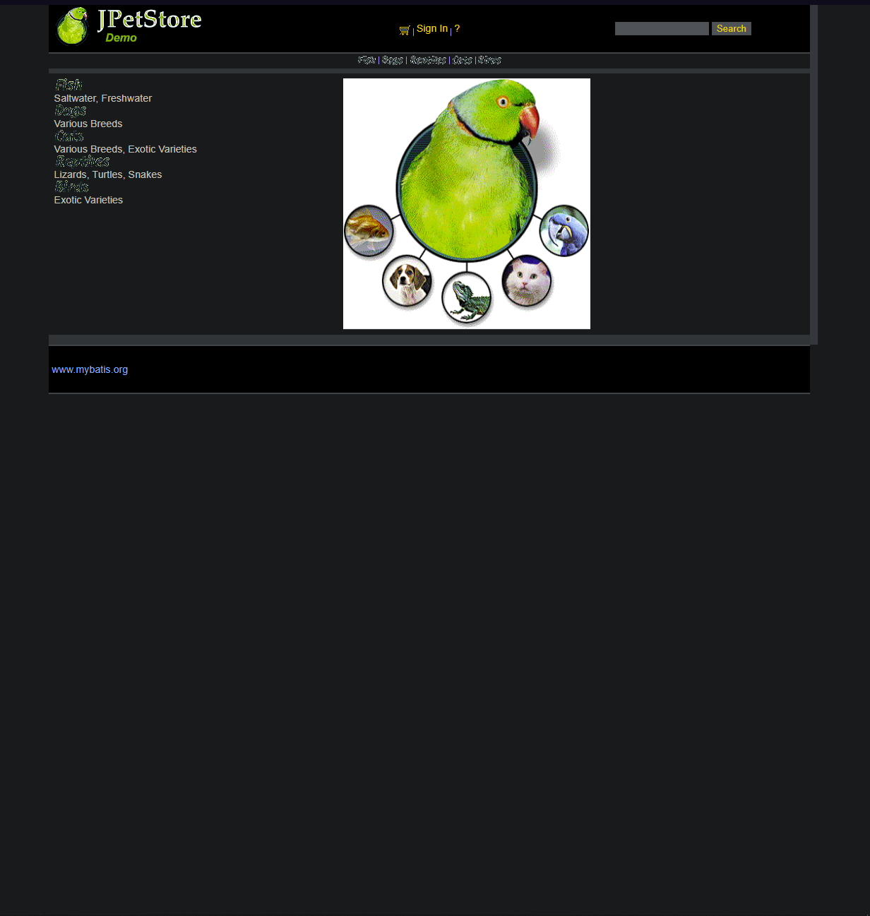**

**Additional Information:**- This issue is consistent and reproducible.

- Clearing browser cache and cookies did not resolve the problem.

- No browser extensions are affecting the login process.

**Priority:**Low

**Severity:**Minor

**Labels:**Bug,Dark mode, UI **BUG 9 - Backend  
Summary: Input fields during registration**

**Description:**The user should not be able to input numbers in name fields and opposite. The user should be also able to see information when inputting details required.

**Environment:** - Chrome : Version 119.0.6045.124 (Official Build) (64-bit)

- Operating System: Windows 10

**Steps to Reproduce:**1. Open the web browser.  
2. Navigate to the (URL:<https://petstore.octoperf.com/>).  
3. Tap on Sign IN

**Expected Behavior:**The user should be able to see information and popup info when inputting characters into the field. Also the users should not be able to input numbers in Name field.

**Attachments:  
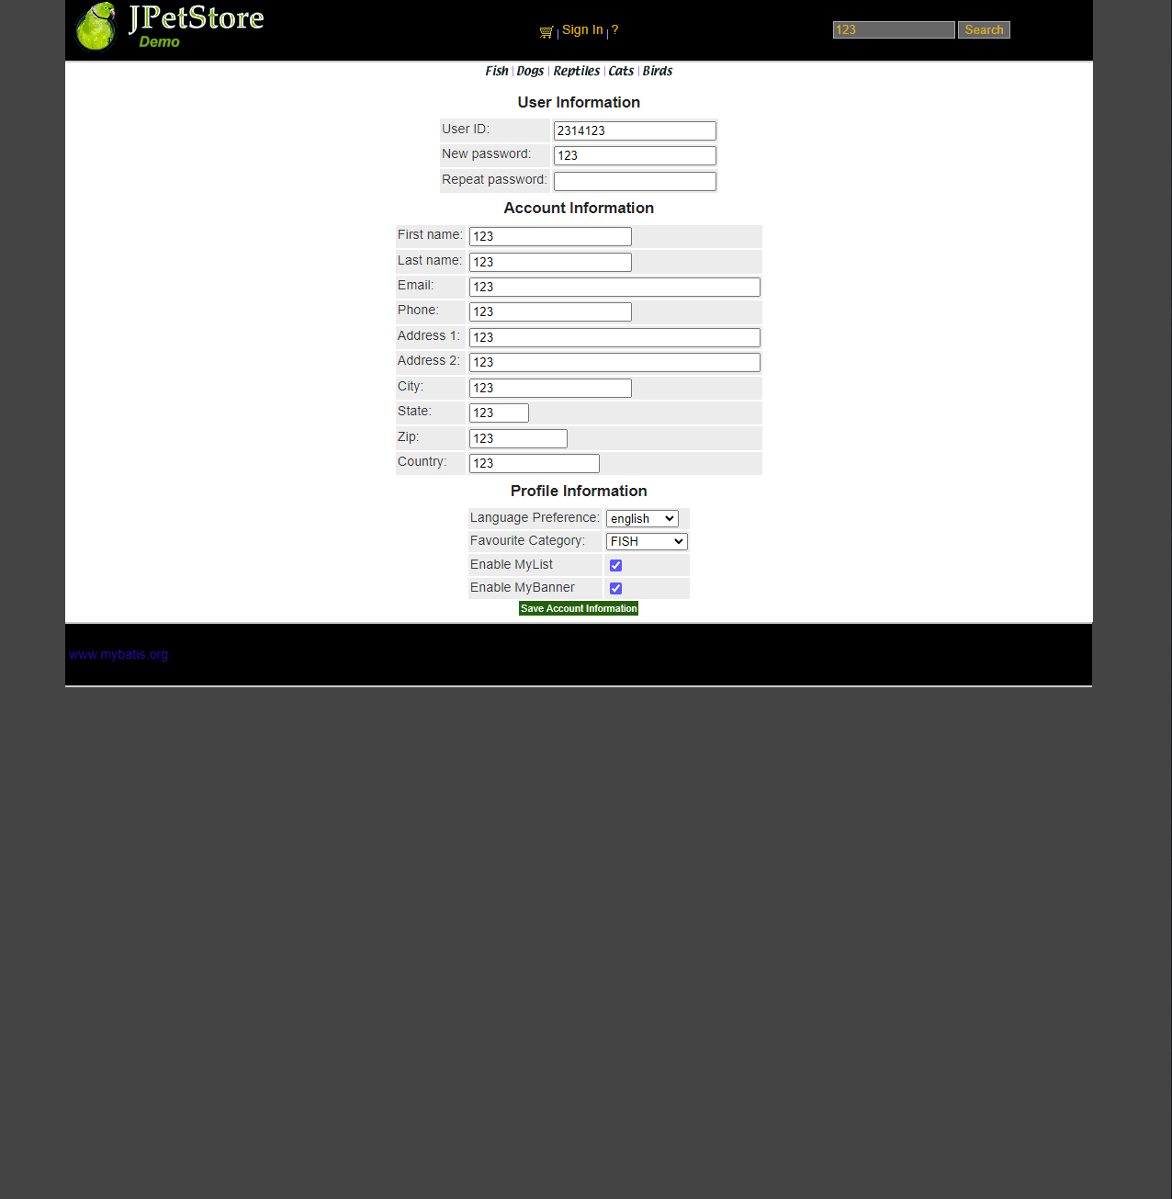**

**Additional Information:**- This issue is consistent and reproducible.

- Clearing browser cache and cookies did not resolve the problem.

- No browser extensions are affecting the login process.

**Priority:**HIGH

**Severity:**Major

**Labels:**Bug,registration,textbox